|  |  |  |  |
| --- | --- | --- | --- |
| **KING SAUD UNIVERSITY**  **COLLEGE OF COMPUTER AND INFORMATION SCIENCES**  **COMPUTER SCIENCE DEPARTMENT** | | | |
| **CSC 329: Computer Network** | **Tutorial 1** | | **1st Semester 1437-1438** |
| **Name:** | | **Student ID:** | |
| **Serial Number:** | | **Section Number:** | |

**Part1: Multiple-Choice Questions**

1. Frequency of failure and network recovery time after a failure are measures of the _______of a network.

a. Performance

b. **Reliability**

c. Security

d. Feasibility

1. Which topology requires a central controller or hub?

a. Mesh

b. **Star**

c. Bus

d. Ring

1. Which topology requires a multipoint connection?

a. Mesh

b. Star

c. **Bus**

d. Ring

1. In a network with 25 computers, which topology would require the most extensive cabling?

a. **Mesh**

b. Star

c .Bus

d .Ring

1. A television broadcast is an example of ________ transmission.

a. **Simplex**

b. Half-duplex

c. Full-duplex

d. Automatic

1. A ________ connection provides a dedicated link between two devices.

a. **Point-to-point**

b. Multipoint

c. Primary

d. Secondary

1. In _______ transmission, the channel capacity is shared by both communicating devices at all times.

a. Simplex

b. Half-duplex

c. **Full-duplex**

d. Half-simplex

1. The Internet model TCP/IP consists of ________ layers.

a. Three

b. **Five**

c. Seven

d. Eight

9) The process-to-process delivery of the entire message is the responsibility of the______layer.

a. Network

b. **Transport**

c. Application

d. Physical

10) The ________ layer is the layer closest to the transmission medium.

a. **Physical**

b. Data link

c. Network

d. Transport

11) Mail services are available to network users through the ______ layer.

a. Data link

b. Physical

c. Transport

d. **Application**

12) As the data packet moves from the lower to the upper layers, headers are _______

a. **Added**

b. Subtracted

c. Rearranged

d. Modified

13) The physical layer is concerned with the transmission of _______ over the physical medium.

a. Programs

b. Dialogs

c. Protocols

d. **Bits**

14) Which layer functions as a link between user support layers and network support layers?

a. Network layer

b. Physical layer

c. **Transport layer**

d. Application layer

15) Which of the following is an application layer service?

a. Remote log-in

b. File transfer and access

c. Mail service

d. **All the above**

**Part2: Exercises**

1. Assume six devices are arranged in a mesh topology. How many cables are needed? How many ports are needed for each device? **15 cables, 5 ports**
2. For each of the following four networks, discuss the consequences if a connection fails.
3. Five devices arranged in a mesh topology

Only one device would be disconnected if all the connections were to fail for that device. You can have many connections to other devices that’s why it’s less likely to fail. The only cause for failure at this point is really the power and if you just don't have any. Even if one of the connections between two devices fail there is no effect on network and they can still communicate through other channels.

1. Five devices arranged in a star topology (not counting the hub)

Star runs to a central device like a switch, so if the switch itself fails then the whole network will be disconnected.

1. Five devices arranged in a bus topology

Bus runs in a straight line from one network device to another. So, if one gets disconnect then the all the devices connected down the line get disconnect.

1. Five devices arranged in a ring topology

Ring is like a bus except it connects back onto itself. So, if one device fails they all fail.

1. Draw a hybrid topology with a star backbone and three ring networks.

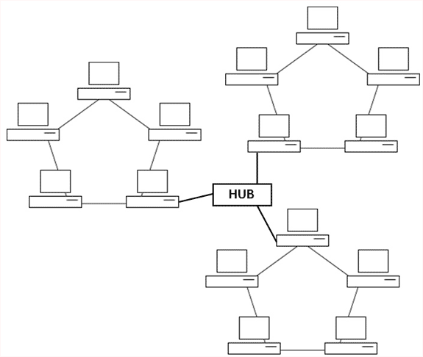

1. Match the following to one or more layers of the TCP/IP model:
2. Route determination. network
3. Flow control. Transport and Data Link
4. Interface to transmission media. Physical
5. Provides access for the end user. Application
6. Reliable process-to-process message delivery. Transport
7. Defines frames. Data Link
8. Provides user services such as e-mail and file transfer. Application
9. Transmission of bit stream across physical medium. Physical
10. Communicates directly with user’s application program. Application
11. Error correction and retransmission. Data Link and Transport
12. Mechanical, electrical, and functional interface. Physical
13. Responsibility for carrying frames between adjacent nodes. Data Link

Figure 1

1. 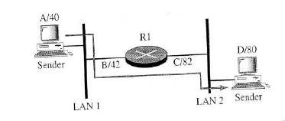In Figure 1, assume that the communication is between a process running at computer A with port address i and a process running at computer D with port address j. Show the contents of packets and frames at the network, data link, and transport layer for each hop.

